

# **Installation instructions:**

1. The system needs the latest version of JRE to be run, download according to your operating system from [here](https://www.oracle.com/java/technologies/downloads/#jdk21-windows).  
   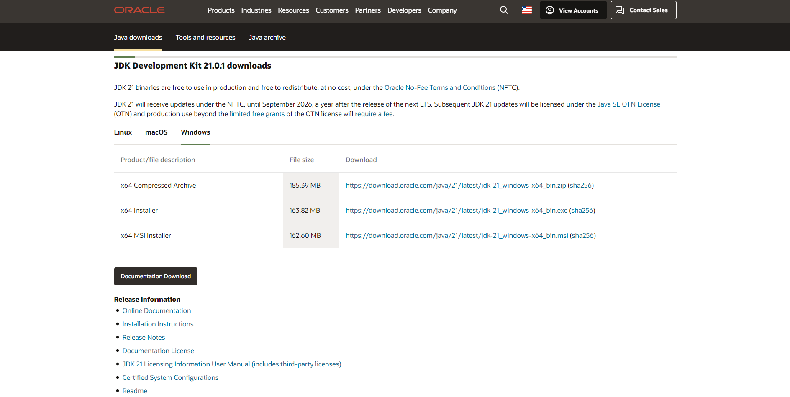

Select the right tab according to your OS, download and install JRE.

1. Double-click on the “SportsFacilityBookingSystem.bat” to run it.
2. To run the source code, open the directory containing the source cope in Eclipse

Note: Keep the bat and the jar file in the same directory to be able to run it!

# **Program Guide**

The program initially has no facilities added, so the first step must be to add the facilities after logging in as an admin.

Note: At any point in the program, to go back enter “/” unless instructed otherwise by the interface.

After launching the program:

Enter 2 to Sign-In

**username : admin**

**password: AstralTrapez0idB0dy**

Enter 1 to add facility

Enter the number of facility you would like to add.

If you want to change the system clock from the local system time to some other time, enter 2

Enter the date in dd-mm-yyyy format (this is the date you are trying to change the system time into)

Enter a number between 0-23 (this is the hour you are trying to change the system time into)

Enter 0 to log out

Enter 1 to Sign-Up

Enter a suitable username of your choice.

Enter a password. Password must not contain any spaces and must have at least 8 characters, at least one uppercase, at least one lowercase letter, along with a number.

To make a booking, Enter 1

Enter the number of the facility you want to book.

Enter the date of booking in format dd-mm-yyyy

Enter the time slot hour you want to make the booking in, the list of available slots only the unbooked slots that are in the future compared to the system time on the same time.

Enter payment method “CC” for visa or “PL” for PayPal.

Enter 2 to view bookings.

Enter 3 to cancel any booking.

Enter the booking ID of the booking to be cancelled. If the booking cancel fails, it means the starting time of the booking is less than 6 hours from system clock.

Enter 4 to check notifications for any cancelled bookings.

Notifications will only appear if you tried to book a slot that was already booked by another customer and the booking holder cancelled their booking.

For example, if you logged in as a customer and made a booking on 17-12-2023 at 14 for a specific facility, then logged out and in again as another customer and tried to make the exact same booking and failed as the slot was already booked, this means you are added to the waitlist. When the original customer holding the booking cancels this booking, the second customer would be notified of this cancellation.

Enter 5 review any completed/past bookings.

Only the bookings that had a starting time that is in the past relative to the system clock will be shown in this list. Enter the booking ID of the booking you want to review, enter a comment, enter a number between 1-5 for rating.

Enter 6 to view any reviews that have been added by customer for a facility.